DCN-Practical-Assignment-1

Task1: Perform the following commands in Command Prompt, analyse and note down the results with all possible options.

- Ping
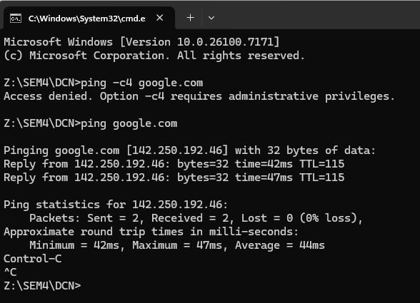

- ping –t (run until break/stop)
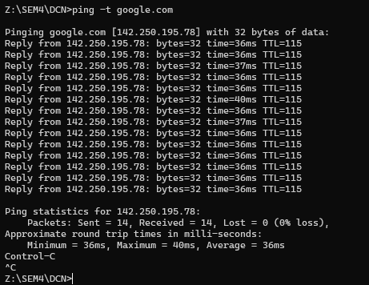

Ping –n (sending n packets)
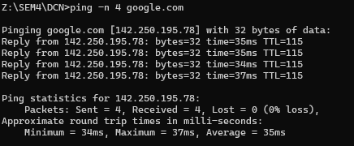

Ping -4 (for force ipv4)
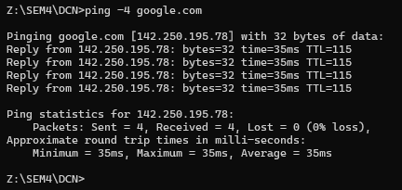

- Ipconfig
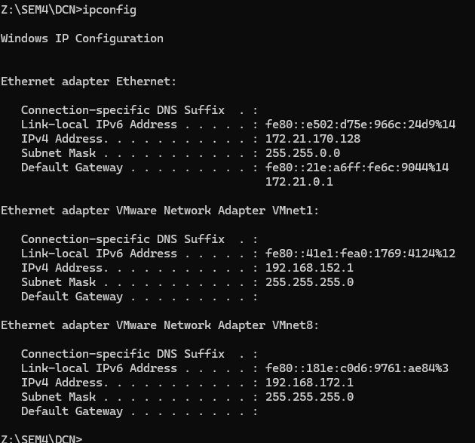
- ipconfig/all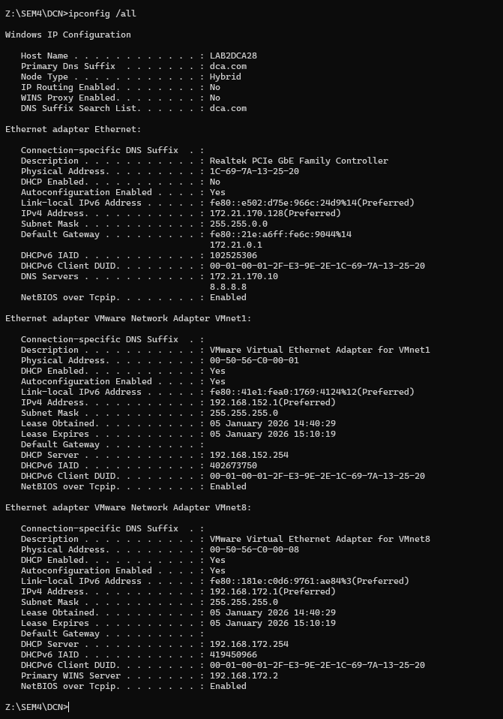

- ipconfig /renew
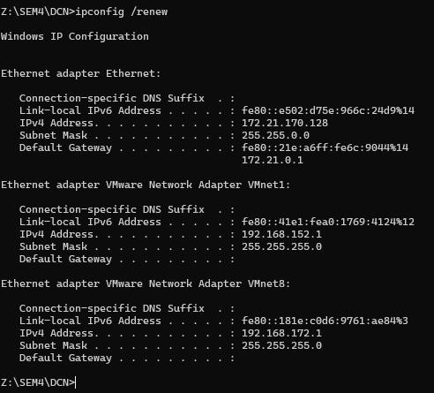

- ipconfig/release
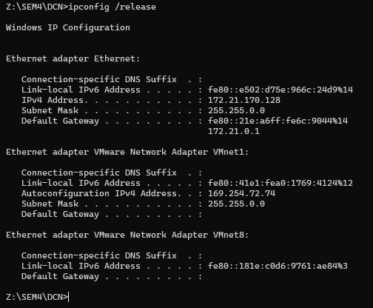
- arp
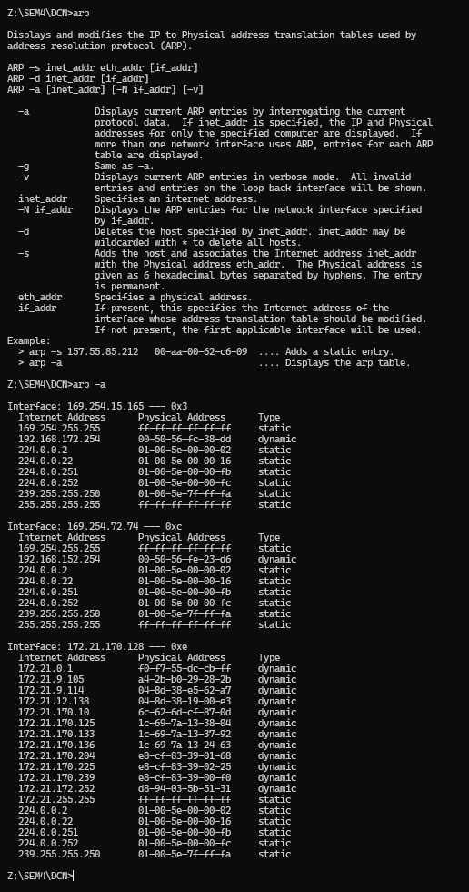
- hostname
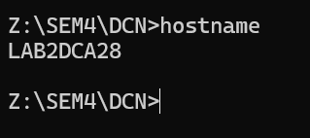

8.nbtstat
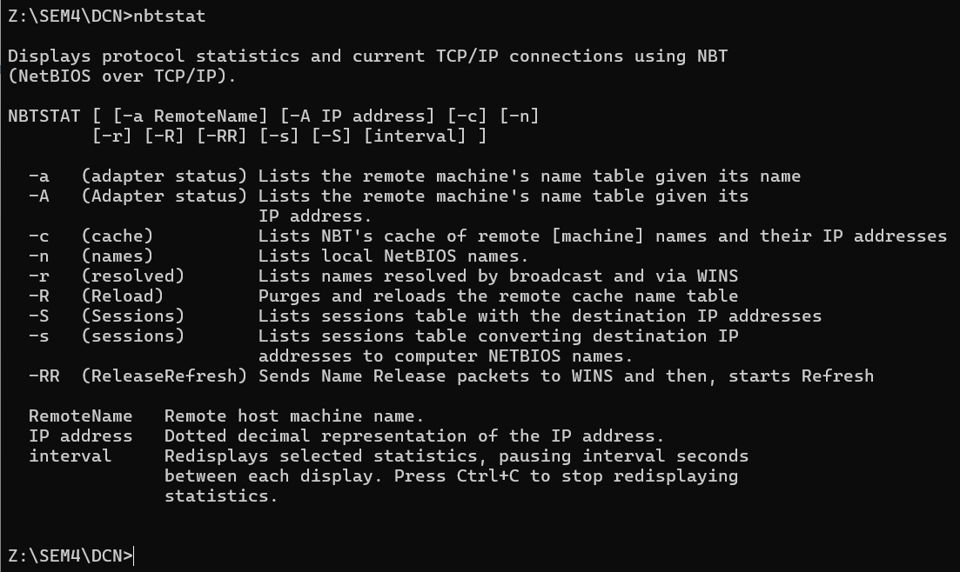

- nbtstat –n (local NetBIOS name)
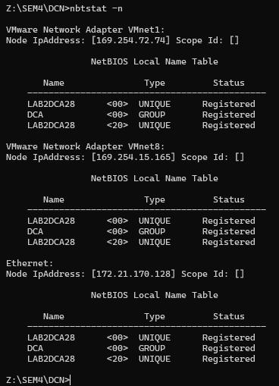

Ntbstat –r
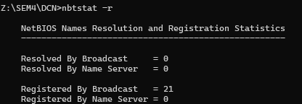

ntbstat –c
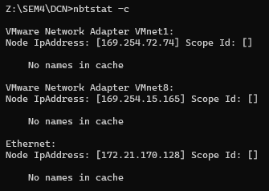

- netstat
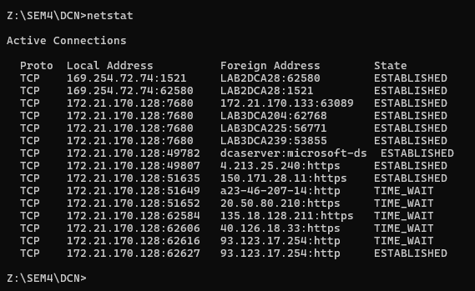
- nslookup
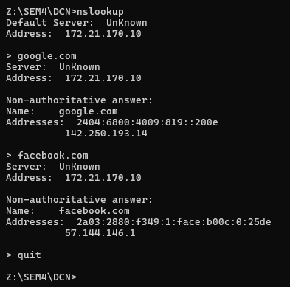

- pathping
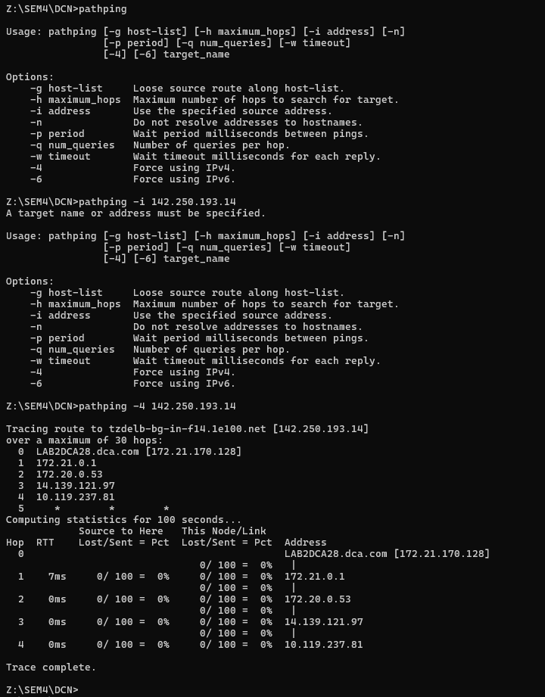


- route
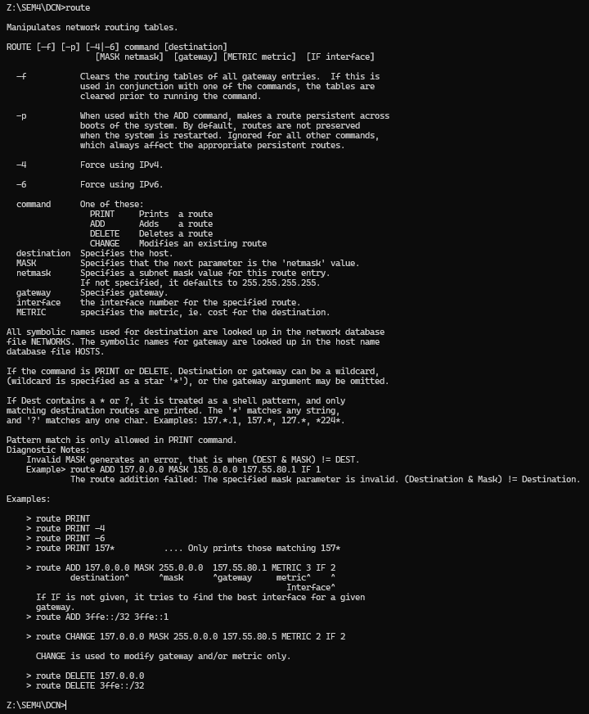

- tracert
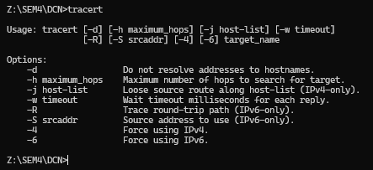
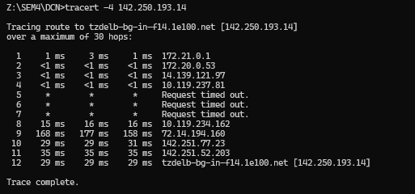

- getmac
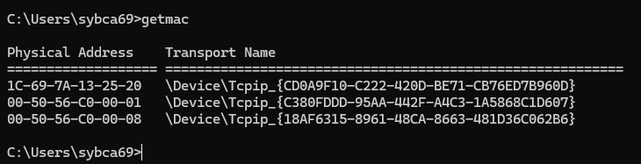

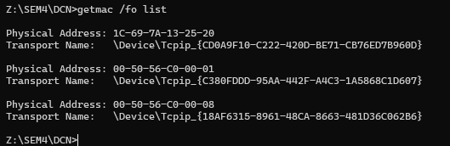
Task2: Overview of Networks and layered communications, understanding of Network equipment, wiring in details. Answer the below questions.

  - Network Hardware: Crimper/clamper, RJ-45 jack male/female, LAN/Cable tester, UTP, Fiber cable, HUB/Switch/Router/Bridge, patch panel, cable manager....
  - Repeaters are simple devices that work at the physical layer of the OSI. They regenerate signals (active hubs do that too).
  - Hubs are used to build a LAN by connecting different computers in a star/hierarchal network topology, the most common type on LANs now a day. A hub is a very simple (or dumb) device, once it gets bits of data sent from
  - computer A to B, it does not check the destination, instead, it forwards that signal to all other computers (B,C,D…) within the network. B will then pick it up while other nodes discard it. This amplify that the traffic is shared.
  - There are mainly two types of hubs:
    - Passive: The signal is forwarded as it is (so it doesn’t need power supply).
    - Active: The signal is amplified, so they work as repeaters. In fact, they have been called multiport repeaters. Hub is a multiport repeater.
  - Hubs can be connected to other hubs using an uplink port to extend the network. Hubs work on the physical layer (lowest layer). That’s the reason they can’t deal with addressing or data filtering.
  - Switches on the other hand are more advanced. Instead of broadcasting the frames everywhere, a switch actually checks for the destination MAC address and forwards it to the relevant port to reach that computer only. This way,
  - Switches reduce traffic and divide the collision domain into segments, this is very sufficient for busy LANs and it also protects frames from being sniffed by other computers sharing the same segment.
  - They build a table of which MAC address belongs to which segment. If a destination MAC address is not in the table, it forwards to all segments except the source segment. If the destination is same as the source, frame is discarded.
  - Switches have built-in hardware chips solely designed to perform switching capabilities, therefore they are fast and come with many ports. Sometimes they are referred to as intelligent bridges or multiport bridges.
  - Most common switching methods are:
    - Cut-through:Directly forward what the switch gets.
    - Store and forward:receive the full frame before retransmitting it.
  - Normal Switches are on the data link layer (just above physical layer), that’s why they deal with frames instead of bits and filter them based on MAC addresses. Switches are known to be used for their filtering capabilities.
  - Intelligent switches work as a router.
  - VLANs (Virtual LANs) and broadcast domains: Switches do not control broadcast domains by default, however, if a VLAN is configured in a switch it shall have its own broadcast domain.
  - VLAN is a logical group of network devices located on different LAN physical segments. However, they are logically treated as if they were located on a single segment.
  - Bridges are used to extend networks by maintaining signals and traffic. Bridges are on the data link layer so in principle they are capable to do what switches do like data filtering and separating the collision domain, but they are less advanced. They are known to be used to extend distance capabilities of networks.
  - In a comparison with switches, bridges are slower because they use software to perform switching. They do not control broadcast domains and usually come with less number of ports. Multiport bridges are generally termed as switch.
  - Routers are used to connect different LANs or a LAN with a WAN (e.g. the internet). Routers control both collision domains and broadcast domains. If the packet’s destination is on a different network, a router is used to pass it the right way, so without routers, the internet could not functions. Routers use NAT(NetworkAddressTranslation) inconjunction with IPM a squer ading to provide the internet to multiple nodes in the LAN under a single IP address.
  - Routers work on the network layer so they can filter data based on IP addresses. They have routing tables to store network addresses and forward packets to the right port.
  - Gateways are very intelligent devices or else can be a computer running the appropriate software to connect and translate data between networks with different protocols or architecture, so their work is much more complex than a normal router. For instance, allowing communication between TCP/IP clients and IPX/SPX or AppleTalk.
  - Gateways operate at the network layer and above, but most of them at the application layer.
  - There is an important rule to obey while using repeaters/hubs to extend a local network and is called the 5-4-3. The rule forces that in a single collision domain there shouldn’t be more than 5 segments, 4 repeaters between any two hosts in the network and only 3 of the segments can be populated (contain user connections). This rule ensures that a signal sent over the network will reach every part of it within an acceptable length of time. If the network is bigger, the collision domain can be divided into two parts or more using a switch or a bridge.

Exercise:
- What are physical layer devices?
- What are the differences between Repeater and Hub? Hub and Switch? Bridge and Switch? Switch and Router?
- Discuss Different Network Topologies

